ASTA 607: COMPUTATIONAL STATISTICS I
ID: 22424180

Question 1
- Codes

#Data description
# (a)

?crabs
Comment:
The crabs data frame has 200 rows and 8 columns, describing 5 morphological measurements on 50 crabs each of two colour forms and both sexes, of the species Leptograpsus variegatus collected at Fremantle, W. Australia.

- Codes

#Loading dataset and checking structure
# (b)

library(MASS)
data(crabs)
str(crabs)

Output
data.frame': 200 obs. of 8 variables:
$ sp : Factor w/ 2 levels "B","O": 1 1 1 1 1 1 1 1 1 1 ...
$ sex : Factor w/ 2 levels "F","M": 2 2 2 2 2 2 2 2 2 2 ...
$ index: int 1 2 3 4 5 6 7 8 9 10 ...
$ FL : num 8.1 8.8 9.2 9.6 9.8 10.8 11.1 11.6 11.8 11.8 ...
$ RW : num 6.7 7.7 7.8 7.9 8 9 9.9 9.1 9.6 10.5 ...
$ CL : num 16.1 18.1 19 20.1 20.3 23 23.8 24.5 24.2 25.2 ...
$ CW : num 19 20.8 22.4 23.1 23 26.5 27.1 28.4 27.8 29.3 ...
$ BD : num 7 7.4 7.7 8.2 8.2 9.8 9.8 10.4 9.7 10.3 ...

Comment:
Structure crabs show 2 factor variables (sp, sex) and 5(FL, RW, CL , CW, BD) numeric variables and one integer(index).

- Codes

#Frequency table table for species and sex
# (c)

View(crabs)
class(crabs)

freq_table <- table(crabs$sp, crabs$sex)
freq_table

Output
freq_table <- table(crabs$sp, crabs$sex)
freq_table

F M
B 50 50
O 50 50

Comment:
Both table(crabs$sp) and table(crabs$sex) return counts of 100 each. The cross-tabulation table(crabs$sp, crabs$sex) shows 50 in every cell

- Codes

#Bargraph
barplot(freq_table, beside = TRUE, col = 5:6, legend = TRUE, xlab = "Species", ylab = "Frequency", main = "Frequency of Crabs by Species and Sex ")

Output
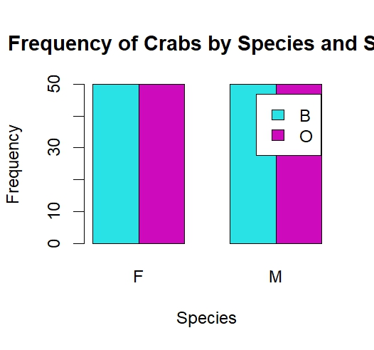

e. The dataset is perfectly balanced, with each of the four groups comprising exactly 50 observations.

Question 2
- Codes

boxplot(BD ~ group, data = crabs,
col = c("red","yellow","blue","green"),
main = "Body Depth by Species and Sex",
xlab = "Group", ylab = "Body Depth (mm)")

Output
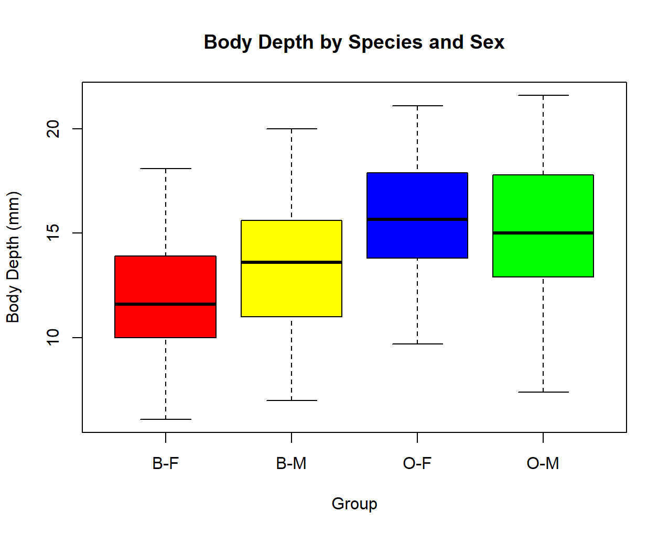

Comment:
The plot shows four side-by-side boxplots for groups B-F, B-M, O-F, O-M. Clearly there no outliers.

- Codes

tapply(crabs$BD, crabs$group, function(x)
round(c(Mean=mean(x), Median=median(x), SD=sd(x), IQR=IQR(x),
Min=min(x), Max=max(x)), 2))

Output
B-F`
Mean Median SD IQR Min Max
11.82 11.60 2.75 3.85 6.10 18.10

$`B-M`
Mean Median SD IQR Min Max
13.35 13.60 3.20 4.60 7.00 20.00

$`O-F`
Mean Median SD IQR Min Max
15.63 15.65 2.75 4.05 9.70 21.10

$`O-M`
Mean Median SD IQR Min Max
15.32 15.00 3.53 4.83 7.40 21.60

Comment:
Outliers: There are no outliers.

Central Tendency: Orange crabs (O-F, O-M) have higher medians than Blue crabs (B-F, B-M). Males sit slightly above females within each species.

Variability: The SD and IQR are quiet similar across all four groups, hence the groups differ mainly in location, not spread.

Question 3
- Codes

par(mfrow = c(1,2))

hist(crabs$CL[crabs$sp == "B"],
main = "Carapace Length - Blue", xlab = "CL (mm)",
col = "blue")

hist(crabs$CL[crabs$sp == "O"],
main = "Carapace Length - Orange", xlab = "CL (mm)",
col = "orange")

Output
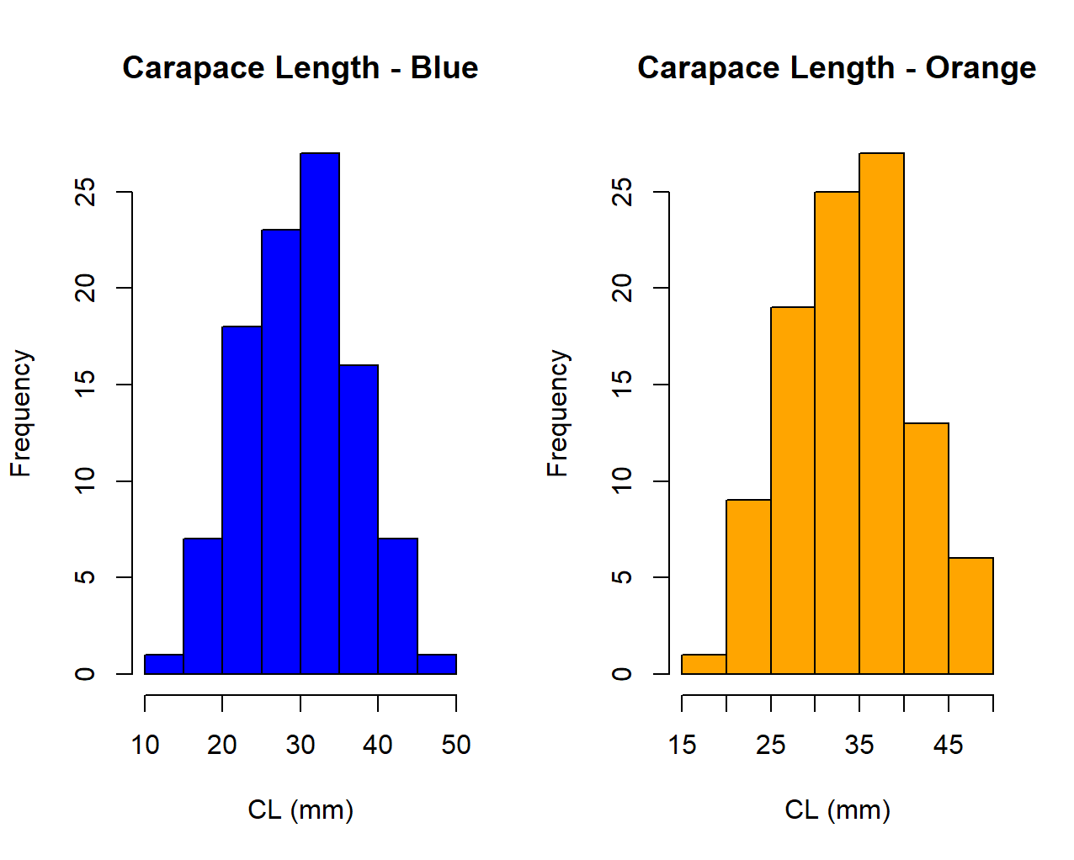
Comment:

Both species show roughly symmetric distributions
- Codes

tapply(crabs$CL, crabs$sp, function(x)
round(c(Mean=mean(x), Median=median(x), SD=sd(x), Skewness=mean((x-mean(x))^3)/sd(x)^3), 3))

Output
$B
Mean Median SD Skewness
30.058 30.100 6.903 0.026

$O
Mean Median SD Skewness
34.153 34.550 6.764 -0.154

Comment:
Both species show unimodal.
Skewness values are closer to 0 which confirms little skew. Orange crabs tend to have a slightly higher mean CL than Blue crabs, but both spread across a similar range.

Question 4
- Codes

means <- aggregate(cbind(FL, RW, CL, CW, BD) ~ group, data = crabs, FUN = mean)
means[,-1] <- round(means[,-1], 2)
print(means)

Output
group FL RW CL CW BD
1 B-F 13.27 12.14 28.10 32.62 11.82
2 B-M 14.84 11.72 32.01 36.81 13.35
3 O-F 17.59 14.84 34.62 39.04 15.63
4 O-M 16.63 12.26 33.69 37.19 15.32

Comment:

- Codes

barplot(means_mat, beside = TRUE,
col = c("red","blue","green","violet","orange"),
,main = "Mean Morphological Measurements by Group",
xlab = "Group", ylab = "Mean (mm)")
Output

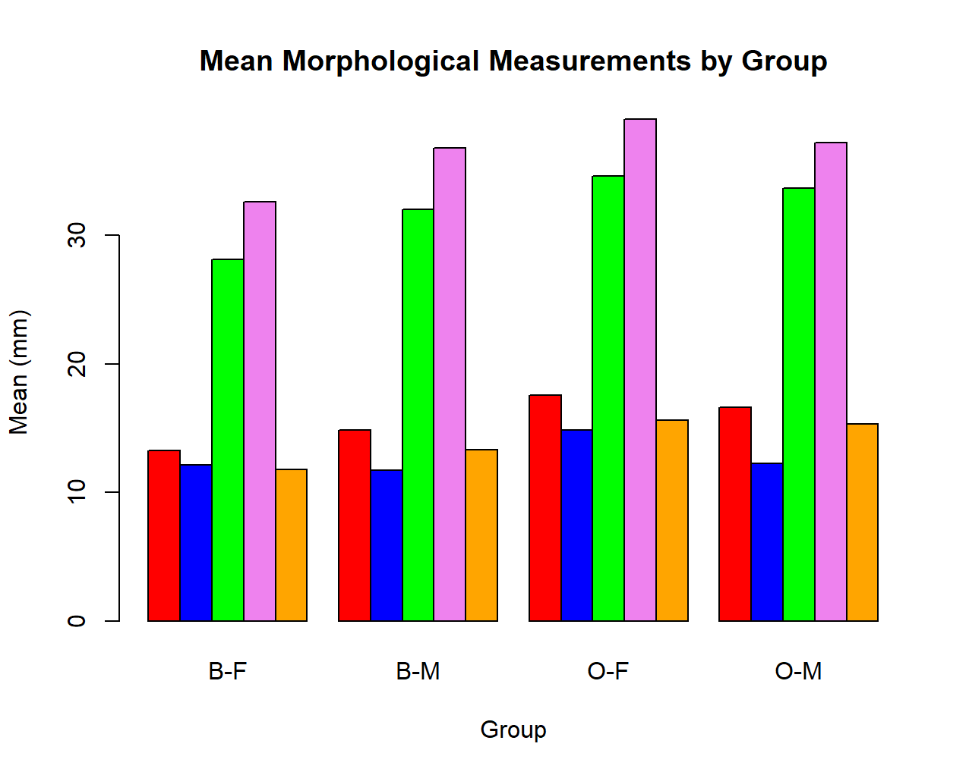
Comment:
The bar chart clearly shows Orange crabs are larger than Blue across all measurements.

- Codes

sp_means <- aggregate(cbind(FL,RW,CL,CW,BD) ~ sp, data=crabs, FUN=mean)
sex_means <- aggregate(cbind(FL,RW,CL,CW,BD) ~ sex, data=crabs, FUN=mean)

sp_diff <- round(abs(sp_means[2,-1] - sp_means[1,-1]), 2)
sex_diff <- round(abs(sex_means[2,-1] - sex_means[1,-1]), 2)
Output
sp FL RW CL CW BD
1 B 14.056 11.928 30.058 34.717 12.583
2 O 17.110 13.549 34.153 38.112 15.478
> sex_means
sex FL RW CL CW BD
1 F 15.432 13.487 31.360 35.830 13.724
2 M 15.734 11.990 32.851 36.999 14.337
> sp_diff
FL RW CL CW BD
2 3.05 1.62 4.09 3.4 2.89
> sex_diff
FL RW CL CW BD
2 0.3 1.5 1.49 1.17 0.61

>

Comment: The sp_diff shows that CL has the greatest species difference, while sex_diff shows that RW has the the least variation between males and females.

Question 5
- Codes

morph <- crabs[, c("FL","RW","CL","CW","BD")]

pairs(morph,
main = "Scatterplot Matrix of Morphological Measurements")
Output
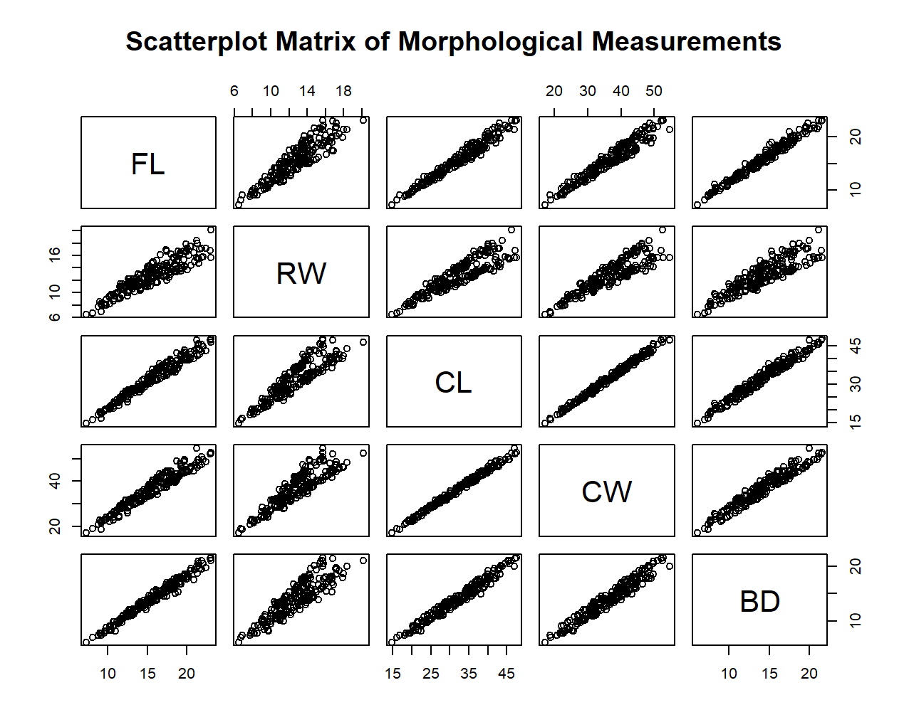

- Codes

round(cor(morph), 3)
Output
FL RW CL CW BD
FL 1.000 0.907 0.979 0.965 0.988
RW 0.907 1.000 0.893 0.900 0.889
CL 0.979 0.893 1.000 0.995 0.983
CW 0.965 0.900 0.995 1.000 0.968
BD 0.988 0.889 0.983 0.968 1.000

Comment:
All correlations are notably strong, indicating robust positive linear relationships among the five morphological measurements.

Question 6
This report presents a comprehensive statistical analysis of the crabs dataset using computational statistical techniques. The dataset contains morphological measurements of the crab species Leptograpsus variegatus, collected from Fremantle in Western Australia. The purpose of the analysis is to explore the structure of the data, examine differences in morphological characteristics across species and sex, and investigate relationships among body measurements through graphical and numerical summaries.
The dataset consists of 200 observations and eight variables. Two of the variables, species (sp) and sex (sex), are categorical, representing two colour forms of crabs Blue (B) and Orange (O) and two sex categories, Female (F) and Male (M). The remaining variables represent continuous morphological measurements, namely frontal lobe size (FL), rear width (RW), carapace length (CL), carapace width (CW), and body depth (BD), together with an index variable used for identification. Examination of the dataset structure confirmed that it contains appropriate numerical and categorical variables suitable for comparative statistical analysis.

data.frame': 200 obs. of 8 variables:
$ sp : Factor w/ 2 levels "B","O": 1 1 1 1 1 1 1 1 1 1 ...
$ sex : Factor w/ 2 levels "F","M": 2 2 2 2 2 2 2 2 2 2 ...
$ index: int 1 2 3 4 5 6 7 8 9 10 ...
$ FL : num 8.1 8.8 9.2 9.6 9.8 10.8 11.1 11.6 11.8 11.8 ...
$ RW : num 6.7 7.7 7.8 7.9 8 9 9.9 9.1 9.6 10.5 ...
$ CL : num 16.1 18.1 19 20.1 20.3 23 23.8 24.5 24.2 25.2 ...
$ CW : num 19 20.8 22.4 23.1 23 26.5 27.1 28.4 27.8 29.3 ...
$ BD : num 7 7.4 7.7 8.2 8.2 9.8 9.8 10.4 9.7 10.3 ...
Table 1: Structure of the data set
An assessment of the distribution of observations across species and sex revealed that the dataset is perfectly balanced. Frequency tables showed that each species contains equal numbers of males and females, with exactly 50 observations in each of the four groups: Blue Female, Blue Male, Orange Female, and Orange Male. This balanced design is advantageous because it allows unbiased comparison between groups without distortions arising from unequal sample sizes. A bar chart illustrating the frequency distribution further confirmed the equal representation across all categories.
 | F | M
B | 50 | 50
O | 50 | 50
Table 2: Frequency table for species and sex
The analysis then focused on body depth to assess morphological variation among groups. Boxplots constructed for the four species–sex combinations revealed clear differences in central tendency across groups. Orange crabs generally exhibited larger body depth measurements than blue crabs, while males tended to have slightly greater values than females within the same species. Numerical summaries supported these findings, showing higher means and medians for orange crabs compared to blue crabs. Measures of variability, including the standard deviation and interquartile range, were broadly similar across groups, indicating that differences were mainly due to shifts in location rather than differences in spread. Furthermore, inspection of the boxplots showed no evidence of extreme outliers, suggesting consistency in measurements across observations.

Figure 1: Body Depth by Species and Sex
To further understand size differences between species, histograms of carapace length were examined separately for blue and orange crabs. Both species displayed approximately symmetric and unimodal distributions, indicating a single dominant size range within each group. Skewness values were close to zero, confirming minimal asymmetry in the distributions. Although variability was similar for both species, orange crabs recorded slightly higher mean and median carapace lengths, suggesting that they tend to be larger on average than blue crabs.

Figure 2: Histograms of carapace length
Mean values of all five morphological measurements were subsequently calculated for each species–sex group. The results consistently indicated that orange crabs possess larger average dimensions across all morphological traits compared to blue crabs. While males generally exhibited marginally larger measurements than females, species differences were substantially more pronounced than sex differences. Comparison of average measurements further revealed that carapace length showed the greatest difference between species, making it an important distinguishing characteristic. In contrast, rear width demonstrated minimal variation between males and females, indicating weak sexual differentiation for this measurement.
Relationships among the five morphological variables were explored using a scatterplot matrix and correlation analysis. The graphical displays revealed strong positive linear associations between all pairs of measurements. These relationships were confirmed by the correlation matrix, in which all correlation coefficients were very high. Such strong correlations indicate that increases in one morphological dimension are accompanied by proportional increases in others. In practical terms, larger crabs tend to be larger across all body measurements, reflecting coordinated biological growth patterns rather than independent development of individual features.

In conclusion, the computational analysis of the crabs dataset reveals clear morphological differences primarily driven by species rather than sex. The balanced structure of the data enabled reliable comparisons, showing that orange crabs are generally larger than blue crabs across all measured characteristics. Body depth and carapace length analyses highlighted systematic differences in size, while strong correlations among measurements demonstrated consistent proportional growth across body structures. Overall, the analysis provides valuable insight into morphological variation in Leptograpsus variegatus and illustrates the usefulness of graphical and numerical methods in exploratory statistical analysis.

